Jenkins UI setup

 Open a web browser, and navigate to your server' IP address. Use the following syntax:

http://ip_address_or_domain:8080

Use the actual IP address or domain name for the server you're using Jenkins on. For example, if you're running Jenkins locally, use [localhost (127.0.0.1)](https://phoenixnap.com/kb/127-0-0-1-localhost):

http://localhost:8080

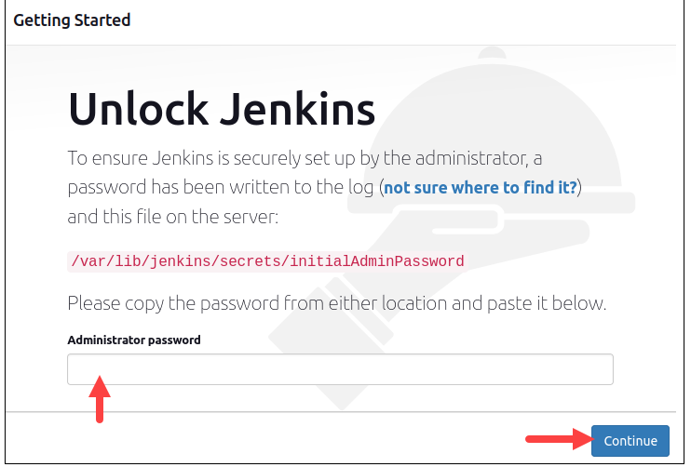

Obtain the default Jenkins unlock password by opening the terminal and running the following command:

sudo cat /var/lib/jenkins/secrets/initialAdminPassword

